MITZVAH DAY
Sunday, March 12, 2023
9:00 a.m. - 4:00 p.m.

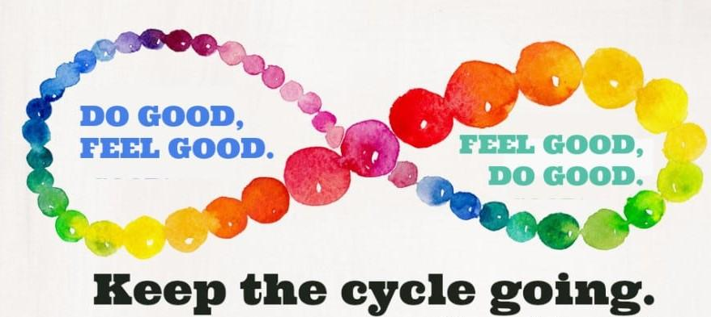

MORNING
PROGRAMS FOR ADULTS AND TEENS
9:00 - 9:30 Bagels and Coffee
9:30 - 3:30 Blood Drive (open to the public)
9:30 - 10:00 Opening Program – Led by Rabbi Kaiserman “Mitzvah Day–One Mitzvah Leads to Another” & Guest Meditation Teacher Rachel Krieger “Spiritual Preparation for a Day of Doing Good”
10:00 - 12:00 What Mitzvot Will Make You Feel Good (AM)?
◊ Donate Blood – NY Blood Center Drive continues until 3:30
◊ Bring Gently Used or New Plastic Toys and Electronics for Children in Need and Earth Day – Second Chance Toys – ToFHY Welcomes all Teens to Help Clean and Prep for Donation after lunch
◊ Stuff Bears for Hospitalized Infants – NY Presbyterian Hospital
◊ Assemble Care Packages for Homeless LaGuardia Community College Students
◊ Crochet/knit Blue Hats for Peace and Quilt Squares and Blankets for Children –Project Linus
◊ Make Cards and Donate Money for our Troops - Eagles Up!
◊ Donate Money for Ukraine – Razom
PROGRAMMING DURING RELIGIOUS SCHOOL
9:00 - 9:30 Tefilah
(over)

9:30 - 9:50 Making Bagged Lunches for Corona Seventh-Day Adventist Church (SDA) and Gift Bags for Seniors – 7th Grade
9:55 - 10:15 Making Bagged Lunches for Corona SDA & Gift Bags for Seniors – 4th Grade
10:10 - 10:20 “Storytime with Lois: Shine Your Light” – Grades K-1
10:15 - 10:35 Making Bagged Lunches for Corona SDA & Gift Bags for Seniors – 2nd & 3rd Grades
10:20 - 10:40 Making Bagged Lunches for Corona SDA & Gift Bags for Seniors – 5th Grade
10:45 - 11:05 Making Bagged Lunches for Corona SDA & Gift Bags for Seniors – Grades K-1
10:45 - 11:15 “Climate Change and How You Can Make a Difference” – Presented by Mark Laster and Eric Arnum, Forest Hills Green Team, and Noah Greene-Hourvas, Fridays for Future – 4th Grade
10:45 - 11:45 “Caring for Newly Arrived, Immigrant Schoolchildren” Speakers: Dominique Fils-Aime, Community School Director, and Yoselyn Vega, Outreach Specialist, Variety Boys and Girls Club at PS112Q
Assembling Hygiene and School Supply Welcome Kits, including Card Making for Elementary Schoolchildren in Astoria - 5th Grade

11:00 - 12:00 “Better Together” Intergenerational Team Program
Making Bagged Lunches for Corona SDA & Care Packages for Homeless Community College Students – LaGuardia Cares – 6th Grade

“Using Your Superpowers: How to Be an Upstander” – Facilitated by Center for Anti-Violence Education– 7th Grade
11:10 - 11:30 “Storytime with Roberta: Shine Your Light” – 2nd & 3rd Grades
AFTERNOON
12:00 - 1:00 Community Lunch for Volunteers
1:00 - 3:30 What Mitzvot Will Make You Feel Good (PM)?
All morning activities listed above, plus:
◊ Assemble School Supply and Hygiene Welcome Kits for Newly Arrived Immigrant Schoolchildren, plus Card Making, PS112Q in Astoria
◊ Prepare Personal Sanitary Items for Girls Worldwide - Days for Girls - Adults and Children 9+
◊ Make Bagged Lunches for Corona SDA (ToFHY, 1:00 – 2:00)
◊ Help Clean and Prep Toys for Donation – Second Chance Toys (ToFHY/Teens, 2:00 – 3:00)
2:15 Violin Youth Concert with Karen Davidowitz at Atria
Junior Choir performs at Forest View followed by Fairview
3:30 - 4:00 End of Day Reflections and Meditation with Rabbi Kaiserman & Cantor Pincus

